Belongly

Standard Form: “Good Faith Estimate for Health Care Items and Services” Under the No Surprises Act

(For use by health care providers no later than January 1, 2022)

Print pages 3 - 8 for your clients

The community for mental health professionals.

A free, secure space for mental health professionals to collaborate with and meet new colleagues, support each other with referrals and stay connected to a trusted network of peers.

Join Today

Belongly.com/start

Appendix 2

Standard Form: “Good Faith Estimate for Health Care Items and Services” Under the No Surprises Act

(For use by health care providers no later than January 1, 2022) Instructions
Under Section 2799B-6 of the Public Health Service Act, health care providers and health care facilities are required to provide a good faith estimate of expected charges for items and services to individuals who are not enrolled in a plan or coverage or a Federal health care program, or not seeking to file a claim with their plan or coverage both orally and in writing, upon request or at the time of scheduling health care items and services.

This form may be used by the health care providers to inform individuals who are not enrolled in a plan or coverage or a Federal health care program (uninsured individuals), or individuals who are enrolled but not seeking to file a claim with their plan or coverage (self-pay individuals) of the expected charges they may be billed for receiving certain health care items and services. A good faith estimate must be provided within 3 business days upon request. Information regarding scheduled items and services must be furnished within 1 business day of scheduling an item or service to be provided in 3 business days; and within 3 business days of scheduling an item or service to be provided in at least 10 business days.

To use this model notice, the provider or facility must fill in the blanks with the appropriate information. HHS considers use of the model notice to be good faith compliance with the good faith estimate requirements to inform an individual of expected charges. Use of this model notice is not required and is provided as a means of facilitating compliance with the applicable notice requirements. However, some form of notice, including the provision of certain required information, is necessary to begin the patient-provider dispute resolution process.

NOTE: The information provided in these instructions is intended only to be a general informal summa- ry of technical legal standards. It is not intended to take the place of the statutes, regulations, or formal
policy guidance upon which it is based. Readers should refer to the applicable statutes, regulations, and other interpretive materials for complete and current information. [Link to IFR when available.]

Health care providers and facilities should not include these instructions with the documents given to patients.
Paperwork Reduction Act Statement
According to the Paperwork Reduction Act of 1995, no persons are required to respond to a collection of information unless it displays a valid Office of Management and Budget (OMB) control number. The valid OMB control number for this information collection is 0938-XXXX. The time required to complete this information collection is estimated to average 1.3 hours per response, including the time to review instructions, search ex- isting data resources, gather the data needed, and complete and review the information collection. If you have comments concerning the accuracy of the time estimate(s) or suggestions for improving this form, please write to: CMS, 7500 Security Boulevard, Attn: PRA Reports Clearance Officer, Mail Stop C4-26-05, Baltimore, Maryland 21244-1850.

2
Belongly

[NAME OF CONVENING PROVIDER OR CONVENING FACILITY]
Good Faith Estimate for Health Care Items and Services

Patient
Patient First Name Middle Name Last Name
Patient Date of Birth: / /
Patient Identification Number:
Patient Mailing Address, Phone Number, and Email Address
Street or PO Box Apartment
City State ZIP Code
Phone
Email Address
Patient’s Contact Preference: [ ] By mail [ ] By email
Patient Diagnosis
Primary Service or Item Requested/Scheduled
Patient Primary Diagnosis Primary Diagnosis Code
Patient Secondary Diagnosis Secondary Diagnosis Code

If scheduled, list the date(s) the Primary Service or Item will be provided: [ ] Check this box if this service or item is not yet scheduled
Date of Good Faith Estimate: / /
Provider Name Estimated Total Cost
Provider Name Estimated Total Cost
Provider Name Estimated Total Cost
Total Estimated Cost: $

The following is a detailed list of expected charges for [LIST PRIMARY SERVICE OR ITEM], scheduled for [LIST DATE OF SERVICE, IF SCHEDULED]. [Include if items or services are reoccurring, “The estimat- ed costs are valid for 12 months from the date of the Good Faith Estimate.”]

[Provider/Facility 1] Estimate

Provider/Facility Name Provider/Facility Type
Street Address
City State ZIP Code
Contact Person Phone Email
National Provider Identifier Taxpayer Identification Number

Details of Services and Items for [Provider/Facility 1]

Service/Item | Address where service/item will be provided | Diagnosis Code | Service Code | Quantity | Expected Cost
 | [Street, City, State, ZIP] | [ICD code] | [Service Code Type: Service Code Number]

Total Expected Charges from [Provider/Facility 1] $
Additional Health Care Provider/Facility Notes

Provider/Facility Name Provider/Facility Type
Street Address
City State ZIP Code
Contact Person Phone Email
National Provider Identifier Taxpayer Identification Number

[Provider/Facility 2] Estimate [Delete if not needed]

Details of Services and Items for [Provider/Facility 2]

Service/Item | Address where service/item will be provided | Diagnosis Code | Service Code | Quantity | Expected Cost
 | [Street, City, State, ZIP] | [ICD code] | [Service Code Type: Service Code Number]

OMB Control Number [XXXX-XXXX] Expiration Date [MM/DD/YYYY]

Total Expected Charges from [Provider/Facility 2] $
Additional Health Care Provider/Facility Notes

[Provider/Facility 3] Estimate [Delete if not needed]

Provider/Facility Name Provider/Facility Type
Street Address
City State ZIP Code
Contact Person Phone Email
National Provider Identifier Taxpayer Identification Number

Details of Services and Items for [Provider/Facility 3]

Service/Item | Address where service/item will be provided | Diagnosis Code | Service Code | Quantity | Expected Cost
 | [Street, City, State, ZIP] | [ICD code] | [Service Code Type: Service Code Number]

Total Expected Charges from [Provider/Facility 3] $
Additional Health Care Provider/Facility Notes

Total estimated cost for all services and items: $

Disclaimer

This Good Faith Estimate shows the costs of items and services that are reasonably expected for your health care needs for an item or service. The estimate is based on information known at the time the estimate was created.

The Good Faith Estimate does not include any unknown or unexpected costs that may arise during treatment. You could be charged more if complications or special circumstances occur. If this hap- pens, federal law allows you to dispute (appeal) the bill.

If you are billed for more than this Good Faith Estimate, you have the right to dispute the bill.
You may contact the health care provider or facility listed to let them know the billed charges are higher than the Good Faith Estimate. You can ask them to update the bill to match the Good Faith Estimate, ask to negotiate the bill, or ask if there is financial assistance available.

You may also start a dispute resolution process with the U.S. Department of Health and Human Services (HHS). If you choose to use the dispute resolution process, you must start the dispute process within 120 calendar days (about 4 months) of the date on the original bill.

There is a $25 fee to use the dispute process. If the agency reviewing your dispute agrees with you, you will have to pay the price on this Good Faith Estimate. If the agency disagrees with you and agrees with the health care provider or facility, you will have to pay the higher amount.

To learn more and get a form to start the process, go to www.cms.gov/nosurprises or call [HHS PHONE NUMBER].

For questions or more information about your right to a Good Faith Estimate or the dispute process, visit www.cms.gov/nosurprises or call [HHS NUMBER].

Keep a copy of this Good Faith Estimate in a safe place or take pictures of it. You may need it if you are billed a higher amount.

Also, Explore The 2022 Mental Health Professionals Industry Resource Map

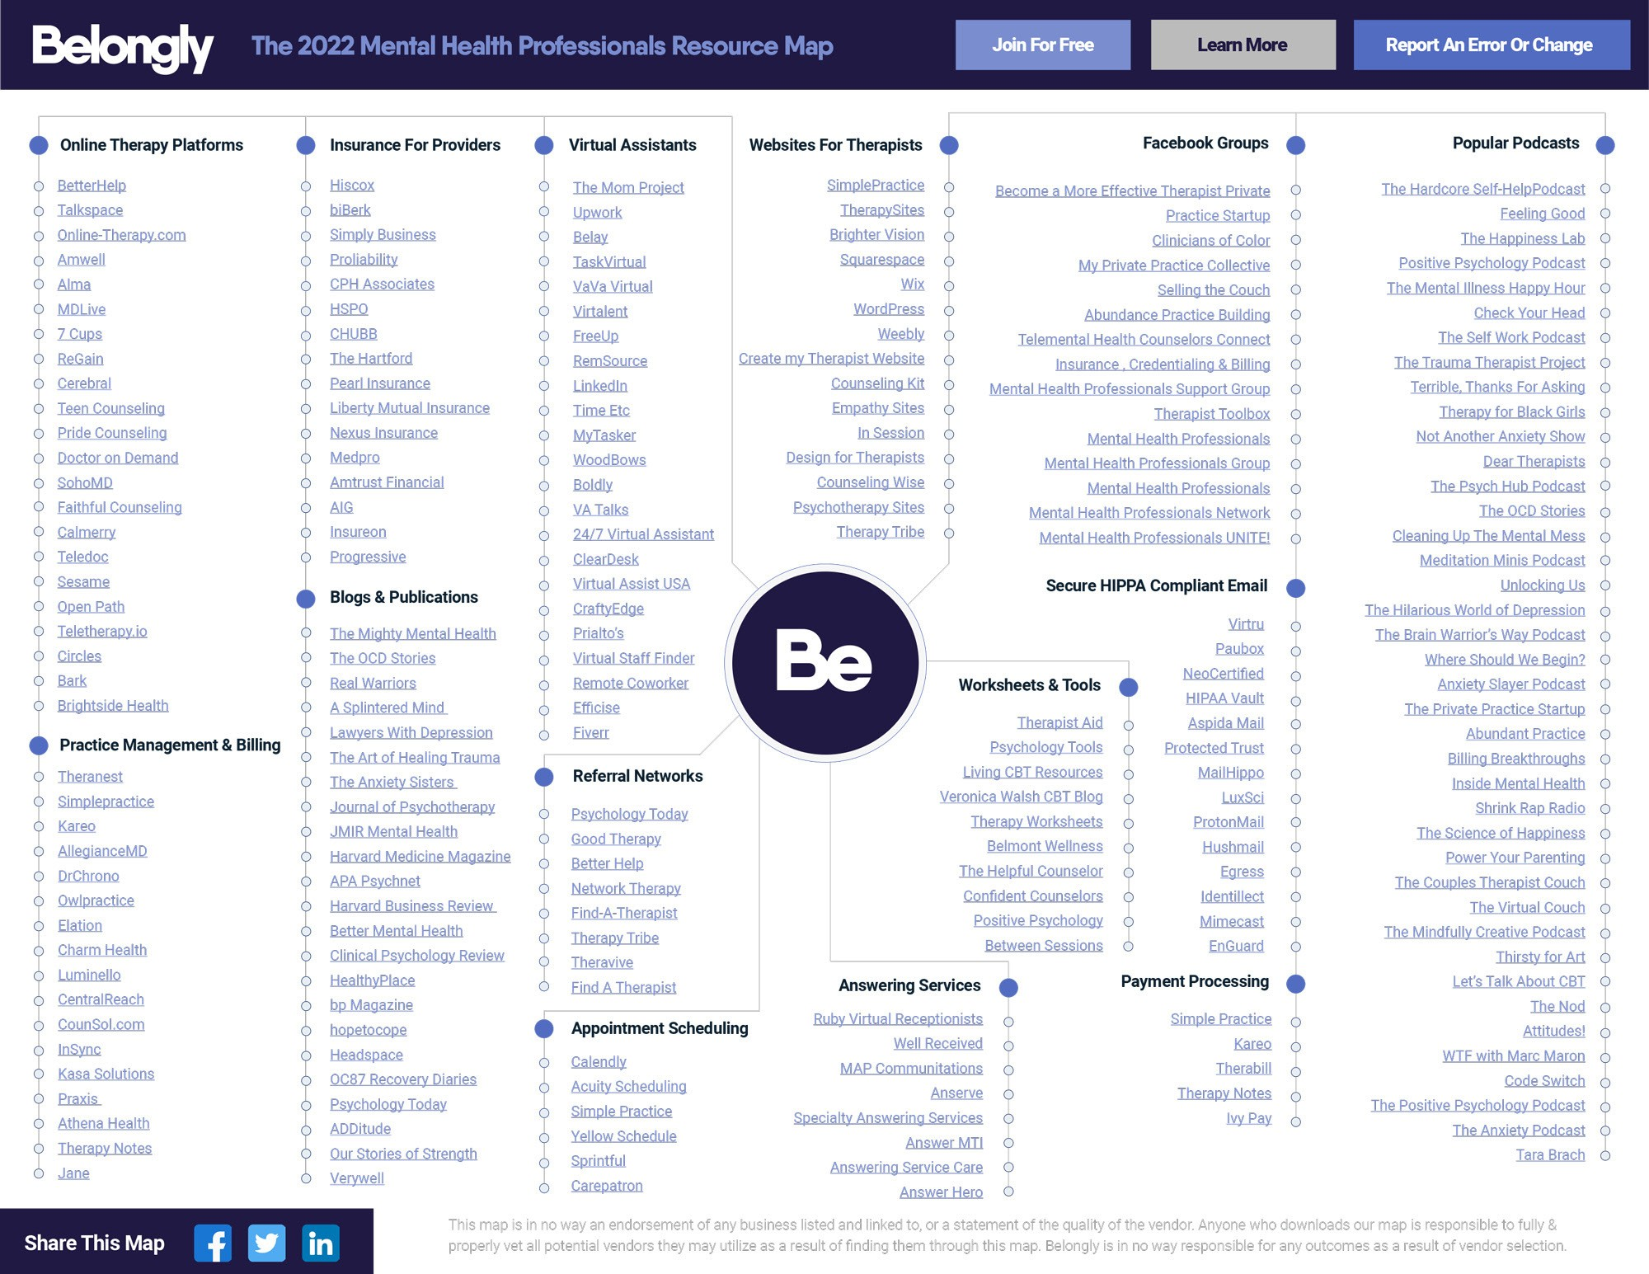

14 Categories, 212 Live Links, including Online Therapy Platforms, Insurance For Providers, Practice Management & Billing Software, Appointment Sched- uling, Virtual Assistants, Blogs, Podcasts, Facebook Groups, Payment Pro- cessing, and more…
To be successful as a mental health professional in today’s environment, it’s increasingly important to be aware of the tools and resources that can power your business and help you run a thriving practice. We’re proud to introduce our 1st annual Mental Health Professional Industry Resource Map. Fresh with new categories, live links, resources, and more information, we’re certain this will give you a big picture of the resources available to you as a therapist to help you run a successful business and stay connected to other professionals.

So, whether you’re practicing as a mental health professional, a professional in another industry, or simply a curious consumer just trying to find out what it’s all about, this PDF (with live links) will help you explore the sites, tools, apps, and resources you need to know There’s a lot to keep up with and our new map gives you a quick way to understand it all.

Download The Map

Belongly
The community for mental health professionals.

A free, secure space for mental health professionals to collaborate with and meet new colleagues, support each other with referrals and stay connected to a trusted network of peers.

Join Today
Learn More

Belongly is a secure private platform. Currently, we only accept US-based therapists.

Connect
Meet other psychologists, social workers, and mental health professionals who share your specialties, interests, and day-to-day challenges.
See who’s on Belongly

Collaborate
Consult on cases, securely discuss specific issues, and learn from a protected space. Help one another by giving and receiving professional support.
Get Connected

Curate
With Belongly, you can find and subscribe to the latest industry news, research, and curated articles you need to stay current and informed.

Subsscribe To Publications

Cultivate
Grow your practice with referrals from the community, and develop your business with tools, advice, best practices, and continued training.

Exchange Referrals

